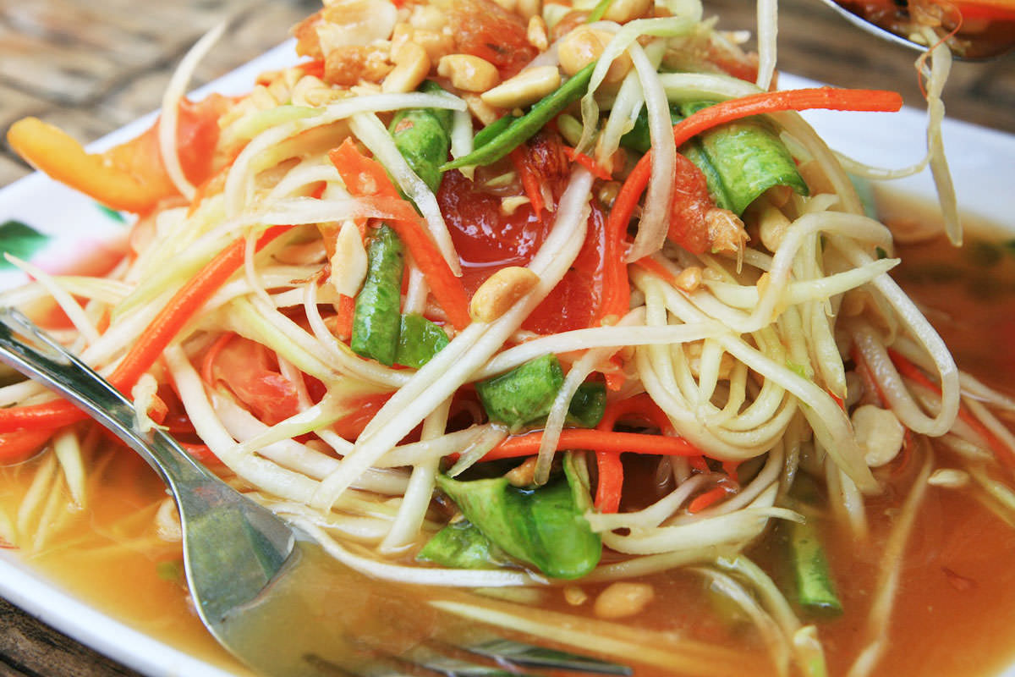  Pad Thai  Serves 2, 350kcal, prep 15 mins, cook 6 mins  Healthy yet delicious version of Pad Thai.  Put the rice noodles in a shallow dish and cover them with water that has just boiled. Leave to soak until soft, about 10 minutes. Lightly coat a wok or deep, frying pan with oil and place over a high heat. Add the garlic, chilli and spring onions and stir fry for 1 minute. Drain the noodles and add to the wok, stir for 2 minutes and push everything to one side. Add the beaten egg and cook for 1 minute stirring all the time until it scrambles, stir into the other ingredients. Add the lime juice, Thai fish sauce, soy sauce, brown sugar and most of the bean sprouts. Stir fry for 1 minute. Stir in the rest of the bean sprouts, peanuts and coriander and remove from heat. Serve immediately. | 100g flat rice noodles (dry weight)  Coconut oil  2 garlic cloves crushed  1 red chilli finely chopped  200g peeled tiger prawns  1 medium egg, lightly beaten  Juice of 1 lime  1 tbsp Thai fish sauce  1 tbsp soy sauce  1 tsp brown sugar  100g bean sprouts  Few sprigs coriander, chopped

